**1 – Arial Black 9, we will add this heading; 2 line spaces after**

**Title: How new social design captures the social with photographs**

Ilpo Koskinen

*School of Design, The Hong Kong Polytechnic University*

*New social design defines “the social” rather than material things as its main design object, and builds usually on ethnographic research techniques in capturing the social. Designers use camera in their fieldwork but unlike social scientists, they build their camera practices on a variety of sources, often artistic and journalistic rather than analytic. This paper explores how new social design captures the social with photographs. It shows that the main unit of social action in photography is the design act. Place on the other hand remains a non-analytic feature that conveys the sense of having been there, but does not go deeper into the social. The most analytic constructs in photographs are diagrams and other representations. Discussion links these observations into the professionalization of design and its aesthetic rather than analytic base.*

**Introduction**

This paper critically explores how social designers capture “the social” – social forms, processes, and structures – with photographs. It studies what has recently been called new social design (Koskinen 2016), which tries to change those social processes and structures that produce outcomes in communities rather than use design for socially responsible causes. A good example is *Nutrire Milano*, a project that created real and virtual food markets between Milan’s Parco Sud and the city. The best-articulated recent approach to new social design is Manzini’s social innovation (Manzini 2015); others include community design (Meroni 2007), collaborative design (Soini 2015), and frame creation (Dorst 2015). The original impetus for the paper was an observation in the author’s earlier work. This observation suggested that new social designers make several aesthetic assumptions about the social; these assumptions in their turn may shape the capturing process in subtle but significant ways.

Approaches vary, but new social design is almost invariably based on ethnography that captures social realities, but its results are typically designs like service and communication processes supported by kilns and buildings. This leads to a two-headed hypothesis about the photographic practices in new social design. On one hand, it may build on the legacy of anthropology and sociology (such as Bateson and Mead 1942; Collier 1967; Ruby 1980; Becker 1986; Harper 2012). On the other hand, it may borrow practices from many sources: documentary and news photography; advertising and product photography; fine art (though old, see Becker 1986); snapshotting (Chalfen 1987); and design (*Presence Project*, 2001). A safe but initial assumption is that photography in social design is mélangeof a several practices, and the way social designers capture the social build on many types of references, some scientific, some aesthetic.

The camera is a heavily used instrument in data production in new social design, but there seems to be no discussion about how it is best used in this role. As an analytic practice, photography in new social design seems to be driven by unspoken-of assumptions about the camera representing reality. In reading social design papers, we routinely see photographs of people, events, places in which they live, design objects of various sorts, and sometimes also links to events and processes beyond the control of the local community. Photographs do constitute a picture of society, but how? How is “the social” captured in the photographs? What kinds of aesthetic choices social designers do and how these choices tell about their interpretation of “the social”?

**Photography: aesthetics and analytics**

New social design borrows its photographic practices from several sources. Their references come from: everyday life (Bourdieu 1990, Chalfen 1987) and their extension to mobile devices (Koskinen et al. 2002; Koskinen 2007); news and photojournalism; documentary photography; fashion and product photography; art1; and the social sciences. Daido Moriyama’s tilted horizons, blurry focus and grainy pictures build on one photographic practice and Gregory Crewdson’s hyperrealism on another. Helmut Newton’s barely-clad models represent sexuality that could hardly be different from Nan Goldin’s drug-infused raw sexuality, or the middlebrow family photographs analyzed by Bourdieu.

This diversity of possible references suggests that the way in which photographs constitute a version of the social depends on what kind practices it is built on. The sociologist Howard Becker once made a plea for theoretically driven visual sociology by pointing out problems in Lee Friedlander’s snapshot aesthetic, which he claimed was analytically inadequate in its reliance on the suggestive power of photography.

Since the skilled photographer can make the image look as he wants it to, and knows he can, photographers should be aware of the social content of their photographs and be able to talk about it at length. As a rule, they are not. One of the foremost recorders of the urban scene, Lee Friedlander, asked to verbalize the explicit social criticism in pictures he seems to make, answered by saying, “I was taught that one picture was worth thousand words, weren’t you?”...

If the above remarks are accurate, then when social documentary photography is not analytically dense the reason may be that photographers use theories that are overly simple. They do not acquire a deep, differentiated, and sophisticated knowledge of the people and activities they investigate. (Becker 1986: p. 242)

An example of what Becker means by deep, differentiated and sophisticated knowledge of the people is Douglas Harper’s *Working Knowledge* (1987), an ethnographic study of Willie, the blacksmith in upstate New York, illustrates the procedural basis of a sociologist with a camera. It is impossible to read this work without studying the photographs that documented in detail Willie’s work, and the workshop environment, and then expanded to see Willie’s work in his community. Harper’s camera traveled through the social in Willie’s world using symbolic interactionist theory as his map (his mentors were Everett Hughes and Howard Becker). This theory helped Harper to direct his camera when he was hanging around in Willie’s workshop and created the critical storyline Becker was calling forth.

Becker’s “deep and sophisticated knowledge of the people” comes from the social sciences and he is certainly right about his critique of Friedlander, whose practice relied on ambiguity and remained in the realm of aesthetic. Yet, there are other types of photographic practices that take photographers to those background scenes that explain social action. In National Geographic for instance, the storyline starts from nature or society, goes to the scientific world, and often ends up in political decision-making. In fine art, artistic projects may constitute a storyline that has some of those analytic properties Becker was missing. For example, Berndt and Hilla Bechers’ *Basic Forms of Industrial Buildings* (2004), a book with hundreds of pictures of industrial buildings, indirectly constitute a vision of industrial past (Becher and Becher 2004) and Richard Prince’s *American Prayer* (2011), a book about myths about sex and the Wild West in American media. Although these practices situate work to media and art world practices rather than to anthropology and sociology, they specify a picture of the social in some way and provide an analytic which, though different from the social sciences, provides an analysis of the social in some way.

If this insight is correct, the way in which the social is constituted in photograph in new social design depends on their research practice. At one extreme are aesthetic practices like Friedlander’s snapshotting (see 2013) that mapped how the Americans use of pictures of JFK in their everyday life. They leave social commentary and analysis to critics, however, and even though they cannot avoid having a picture of the social, aesthetic practice gets foregrounded. Somewhere in the middle are photographic practices that build on journalism and artistic practices like that of Prince or the Bechers. Here, photographs participate in a storyline telling about the larger society, but how this happens depends on the storyline. Finally, at the other extreme are photographic practices that build on the social sciences. In these practices, the camera can go to considerable depths of the community, as in Douglas Harper’s study of Willie or Mitchell Duneier’s *Sidewalk* (2001), which documented the live of black book vendors in the streets of New York. In these practices, social theory directs camera work, while aesthetics remains a matter of choice rather than the guiding principle of photography.2

**Materials**

The material for the paper comes six papers in a Special Issue of Social Design in the *International Journal of Design* edited by the author and his colleagues (ijdesign.org/ojs/index.php/IJDesign/, Vol 10(1), April 2016). The purpose of the issue was to take a stock of social design and its recent developments. Selected from 79 original submissions, these six papers described fieldwork and construction with local craftsmen in communities in China, Taiwan, Brazil, Australia, England, Sweden, Finland, and Scotland. There were about 80 photographs in these six papers that are freely accessible online, but it is difficult to give an exact number because of several collages with gradients that blur the lines between photographs. 34 photographs had people in them, and designers appeared in 27 photographs.

Picture 1 is a typical photograph in the collection. It comes from a design case study of Umeå Pantry, a folkloristic museum with several activities in the Northern Swedish town of Umeå. The picture shows a part of the pantry, where some of its collections and sellable items were on display. The photograph has no people, the lights are on, and the angle captures some shelves, a table, and a cooking pot, all located in an old wooden structure. The caption described these as the pantry’s “physical infrastructure.”

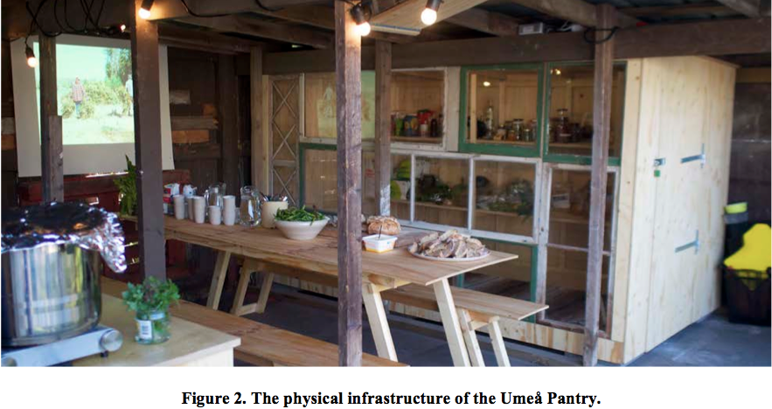

**Picture 1.** Umeå Pantry from Pawar and Redström (2016)3

Like in Picture 1, photographs in the Special Issue were almost invariably realistic and built on snapshot aesthetic. The photographers used pocket cameras, mobile phones, or regular 35 or 55 mm cameras and 3:2 or 16:9 picture formats. The photographs were captioned and explained and the narrator in captions is omniscient and impersonal rather than reflective or playful. There were few deviations from this format, most notably collages and storyboards, but these were rare. One possibility is that this realistic aesthetic was meant to convey an image of scientific practice and the sense of having been there. Usually, captions remain tied to what can be seen in the photographs, but they sometimes expand the interpretation by framing it with terms like “physical infrastructure.”

**The design act as the basic social unit**

Looking at how photographs picture the social, their unit of analysis is typically a design act organized by the designer: workshop, co-design session, role-play, or some kind of construction event. This practice reduces the social to design activities, and represents a move away from user-centered design towards a designer-defined point of view.

Picture 2 is from Rio de Janeiro. We see a designer leading a workshop exercise for children. This is the most typical organization of activities we see in photographs. The constants are designers, a group of people, and some kind of design activity in which people participate. Mostly, photographs show designers working with people with post-its, legos, games, scale models, or construction sites. Photographs in new social design routinely show designers, student groups, lectures, presentations, co-design teams, and designers testing interactive technologies like radios. Also photographed are events and in the case of China, groups of people. Designers drive the action, while the background fades away. Note also how the caption distinguishes the designer, leaves the photographer inexplicit, and distinguishes them from “local people” whose relevance stems from that role.

The closest equivalent to this aesthetic is probably snapshot aesthetic in art. If we look at individual photographs, the photography is similar to the aesthetic of, say, pictures in Robert Frank’s *The Americans* (2015), Nan Goldin’s *The Ballad of Sexual Dependency* (2012) or Larry Clarke’s *Tulsa* (1971). We see tilted horizons, out-of-focus, natural lighting, “bad” posing, the photographer’s shadows, and so on. The pictures are grainy, shot from the hip, sometimes from the movement, and they are not edited for their deficiencies.

These photographers, though, approach their subject through a project that generates an analytic frame. In new social design in contrast, photography serves the project in a supplementary and documentary format rather than works as an independent element. Here the practice departs from art, but also from news photography, documentary, and the social sciences. There, the storyline – and the analysis – tells where the camera goes, but in contrast to these, it keeps its snapshot like character; here, the camera captured the community through by focusing the lens on designers.

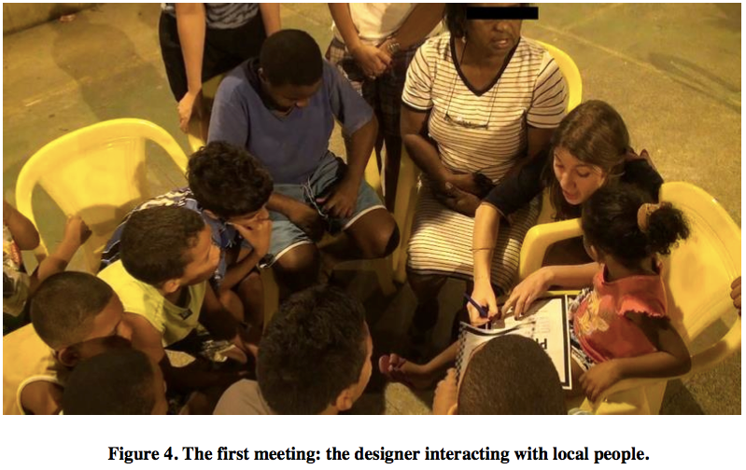

**Picture 2.** Workshop in Rio de Janeiro (del Gaudio et al. 2016)

As such, this fits the nature of the discipline of design. Design is a discipline that aims at making a difference. It is natural that they focus their cameras on the supposed cause of changes, which is their intervention. Other aspects of action get much less attention, and in this sense, the realism behind photographic practice is biased, and prioritizes one version of the social rather than aims at a balanced view. This may reflect the reality, of course, but it may also lead to unbalanced and even misleading narration. If the actions of community leadership, management structures, and any other lines of action that are initiated outside the immediate context of the design work are left out of the narratives, the social gets a very narrow interpretation, as a recent PhD thesis which followed the aftermath of a design project for years (Soini 2015) has beautifully shown. As Dawn Nafus pointed out to me in her comment to this paper, however, it may also be that focusing on the design act may in some sense be more honest than some of the alternative photographic practices. For instance, giving participants disposable cameras and telling them what to photograph hides a good deal of the designers’ work in instructing and editing the photographs, and generates little contextual knowledge. Keeping the camera in the hands of the design team forces the designers to think about what to capture and show. Yet, current photographic practice in new social design concentrates on the design act rather than goes on to illustrate those underlying processes Becker was missing.

If this is correct, it leads to our next question. There is no doubt that other aspects of “the social” are relevant to design too, and if new social designers for sure want to change them, they have to have an idea of these aspects. How does the camera capture larger realities beyond the design act?

**The scenic place**

Looking at the images in the Special Issue, the answer is that these larger realities enter the narrative through several notions of place rather than social organizations. Papers in the Special Edition contain lots of photographs of the places in which action happens. These places are streets, buildings, rooms, and many types of workplaces. The social context, then, is not empty, but inhabited by places. Again, the question is how are these places exhibited, and what do they tell about the social?

Picture 3 is from the same social design project as Picture 2. It is a village scene that shows the square in which the project was taking place. There are a few people in the picture, but they are all absorbed in their own activities, and it remains unclear why they are there. The surrounding text tells about the village, but does not tell why this photograph has been selected for the article, and the caption dryly tells it is a “view of the square.”

This photograph works very much like in descriptions of exotic settings in the romantic mode of early anthropology Geertz described (1986: 1-17): it shows that the researchers were there, but not much more. Later in the papers, this place becomes the stage in which designers do their work, but unlike in Harper’s *Working Knowledge* or Mitchell Duneier’s *Sidewalk* (2001), the camera does not follow the storyline to make connections from action to their background. Instead, visual narrative remains fixed to space, which is not treated analytically.

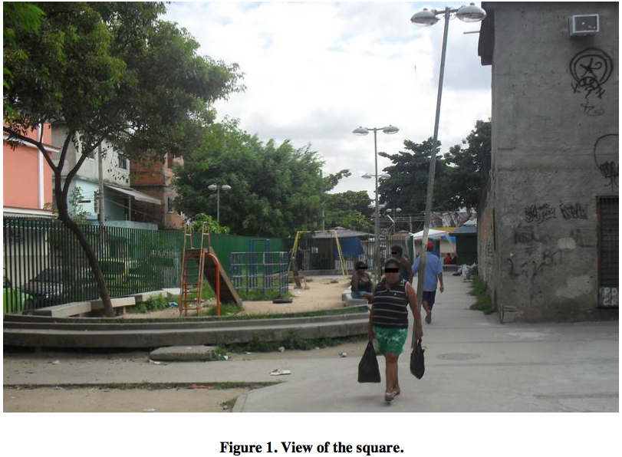

**Picture 3.** The scene of a design project in Rio (del Gaudio et al. 2016)

The difference to visual practices in art is also pronounced. These photographs lack the suggestive power of Stephen Shore’s *Uncommon Places* (2012), a study of common deserted places in America, Joel Sternfeld’s *On This Site* (2012), a study of how murder sites look like years after the horrors, or the documentary value of Bernd and Hilla Bechers’ studies of abandoned industrial facilities in the Ruhr area in Germany that grow into a commentary of deindustrialization and its stony corpses (see Becher and Becher 2004).4

In contrast, in new social design, photographs paint place as a container in which things happen rather than an analytical device by, for example, juxtaposing privileged and underprivileged areas, or by showing social activities as they evolve in this place. The place remains a scenic feature (Sharrock and Anderson 1994) rather than a scene with layers of meaning behind the visible front of activities. Furthermore, it remains unclear who are the people in photographs, why they have been chosen, what they are doing, and how what they do relates to the design project beyond illustrating design activities and the settings in which they happen.

One possible reason for the discrepancy between text and photographs may again be designers’ theory about action. For them, the relevant part of action is what they are doing rather than the community and its complexities. By flattening the context, photographs come indirectly to highlight design as the main locus of action and, by implication, the driver of change. Another possible reason is that the design practices behind the papers all build on co-design and co-construction, both heirs of the user-centered practices of the 1990s (see Meroni 2007; Soini 2015). These methods push designers to fieldwork, but this fieldwork focuses on the interface between technology and people and how designers work in that interface with objects, co-design practices, and other types of props. With the exception of technology, the links to social forces behind situations tend to remain untheorized in these practices.

**Flat societies: the social on paper**

Perhaps the greatest gap between new social design and anthropology and sociology exist between how they treat the social background of action. Because new social design wants to work with structures and processes that shape those situations people encounter, they should situate their activities to these contexts that are crucial to the success of new social design projects. They also follow social organization conscientiously.5 For example, Andrea and Marcelo Judice (A. Judice 2014; M. Judice 2014) worked with doctors and health agents to find ways to combat tuberculosis in Vila Rosario, Rio de Janeiro. The Brazilian League Against Tuberculosis funded the clinic, while the Ministry of Education of Brazil funded the Judices. Their text is full of references to institutions including the city, the police and the church, but their camera stayed in Vila Rosario.

The expectation for camera work is clear, if the measure is the analytic photographic practice Becker was missing in his critique of Friedlander: the camera should also track and record these institutional links. However, this is not usually the case. With few exceptions, the camera does not follow social organizations around action. It is either absent, or it is treated as an undifferentiated mass. For example, there must be several social organizations in Picture 4, but these are not explained in the photograph or in the caption. Here instead, the caption tells about innovation platform, which turns the picture social.

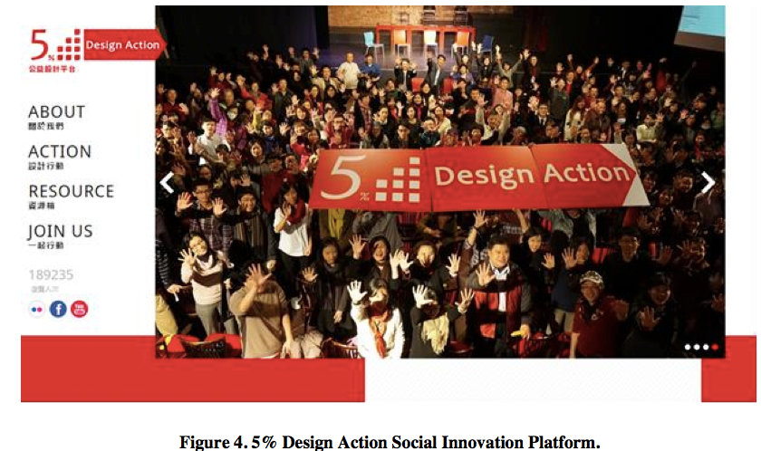

**Picture 4.** The Main page of the Design Action site, Taiwan (Yang and Sung 2016)

When we turn to the materials however, we find practices that stay close to the lived reality of the design process. Thus, although we find hints of institutions in text, we also find a discrepancy between the text and the visual storyline. The latter remains tied to easy-to-see things, and does not take us to the back regions in which activities are prepared. The camera stays within what is understandable with lay sociology or anthropology. Chen et al. have recently speculated about the reasons why social design stays in the scale of the village:

Designers seem to be well equipped to deal with what the early sociologists would have called *Gemeinschaft*, communities characterized by what one of the founding fathers of sociology, Émile Durkheim... called mechanic solidarity. In these small communities, people know each other and can anticipate the consequences of their actions on other people by relying on lay sociology. Designers are much weaker when they work in the *Gesellschaft*, or societies characterized by what Durkheim called organic solidarity. Here, actions are parts of long chains of action and rules of governance that make it difficult to see the consequences of the actions... If this observation is correct, social design in its current stage may do well at the scale of a village or an informal organization, but its prospects of success are far smaller when it has to deal with the abstract structures of governance typical to late modernism. (Chen et al. 2016: 3).6

Yet, even in this small scale, photography remains tied to design activities. It does not take researchers out of the design world in the manner Larry Clarke’s *Tulsa* (1971) took us to the seedy, drug-infested side of sexuality in the town of Tulsa

The main practice that takes designers out of the design act are graphs of stakeholder networks (these are often inspired by actor-network theory (Latour 1987), so they include not only people, but also things), and photographs of these graphs, as in Gordon Hush’s work in the Western Islands in Scotland. The project was designing ways to keep the small islands on the Western archipelago inhabited (see Koskinen and Hush 2016: 68-69). The project aimed at locating underused neighborhood resources that could be turned into public goods. The project built on Frisby’s (1988) Marxist analysis of the UK.

The project used photographs in ways that were considerably more analytic than the scenic photographs we have seen so far. For designers, photographs are also material that can be augmented by drawings and graphic elements. They can also appear in collages, as in Picture 5, where we see a network map, beach scene overlaid with colored graphic circles, and a graph of the structure of proposed design direction. This picture gives a rich picture of Colonsay and its social organization, even though it makes no connections to social theory.

This is the best – and almost the only – example of an analytic use of photography in the Special Issue that takes design out from the local circumstances to larger social contexts. The photograph in the collage is a straightforward beach scene, but the visual context gives it qualities that go beyond the scene. The photograph is typical to design in several ways. First, it is in a projective context: it shows how some things are in Colonsay, but it also proposes new lines of action. Second, it does not make a difference between design imagination and reality. Third, it is not precise about the linkages between the scenery, networks, and proposed actions, but remains sketchy, as design often does in the research phase.

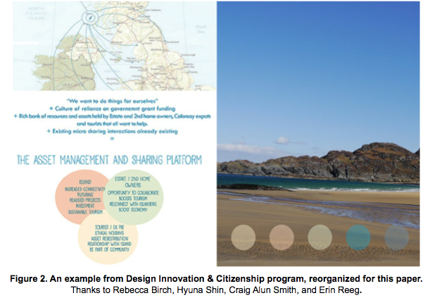

**Picture 5.** Stakeholder map of Colonsay, Scotland (Koskinen and Hush 2016)

**Discussion**

This paper began as a question about the aesthetic of photography in new social design. Looking at possible references designers can use to build up their photographic practice, we saw a range from mainly aesthetic visions of photography to versions where the social is the main focus. By building on Howard Becker’s (1970) observations of photography, the paper distinguished several types of possible photographic practices. At one end, we find snapshot-style practices that serve to witness that the designers were there (Geertz 1986), but keep the focus aesthetic rather analytic, as in Lee Friedlander’s work discussed by Becker (see Friedlander 2012). At the other end, we find practices in which the camera is guided by some kind of social theory that helps designers show the dense social mesh around their work. Aesthetics gets a secondary role in this kind of practice, which is exemplified by professional social scientists like Douglas Harper (1987, 2012) and Mitchell Duneier (2001). Between these extremes are research practices in which the camera follows some kind of storyline that guides the camera through the social, but does not build explicitly on theory.

Perhaps the most interesting observation of the paper is that the camera mostly follows designers and the context in which they work. The focus of photography is the design act, which is documented in photographs that leave the larger social context largely invisible. Even the place in which design work is done remains mostly a scenic feature (Sharrock and Anderson 1994). Photography in new social design has similarities to snapshot aesthetic in art. We see tilted horizons, bad lighting, wrong color temperatures, the designers’ shadows, and many types of odd framings. These photographs, however, used few techniques of creating distance from snapshot or conceptual art. The camera seems to be taken as evident and the photographic practice remains non-analytic.

This may give some clues that help to find the roots of the practices described in this paper. One possibility is the methodic legacy of co-design and co-construction, both heirs of earlier user-centered practices (see Meroni 2007; Soini 2015). In these design approaches, designers leave the studio to do fieldwork, which usually remains tied to the immediate use situations of technology, and sometimes their technical background rather than the larger society. If this speculation is correct, it may be understandable that the camera is used to document design work and how it happens. Indirectly, however, it gives designers the forefront and builds the drama around them rather than the social activities and organization of the community. The camera proves that the designers have “been there,” as Geertz (1986) put it.

This conjecture may also identify one limit of current design practice. As Chen et al. (2016) have observed, new social design tends to remain tied to small-scale communities that can be understood without theoretical references from the social sciences. If this is true, photography may work against the main purpose of new social design: if it does not go beyond readily seeable encounters, it may miss those social processes that generate them in the first place. In the context of design, new social design contains a massive promise. It is building up new types of practices that may help in contextualizing design better by situating them into those underlying processes that generate observable situations, events, objects, spaces and processes. If research is kept too close to the design act, however, research practice fails to support the promise.

Another issue to think about is the relationship of design to social change. New social designers (and designers in general) see themselves as change-makers, whose work is designed to make a difference. From this perspective, it might well be that even the camera is meant to participate in the professional project of design. It proves that designers have been in the field, they have taken many types of actions, and they have initiated and steered social change. Because it refrains from suggesting changes in power structures behind the ills designers observe, it has a delibitating effect on the very thing new social design tries to achieve, change. The practice may have roots in the commercial assumptions of professional design, in which questions about power and social embeddedness are either irrelevant or might be seen as threats to business purposes. This works with the politics of many new social designers, but not all: many new social designers find their theoretical roots from Marxism through participatory design, and through Chantal Mouffe’s “agonism” from the structuralist Marxism of Louis Althusser and Ernesto Laclau (see Koskinen 2016). In the corpus collected for this paper, there were no agonistic papers, however, so the question of how the camera captures the social in this strand of design has to be left open.

If the writer is correct, this paper is the first exploration into how new social designers use the camera in their work to depict their object of design, the social. New social design aims at changing the social to improve the world, and it cannot avoid building on some notion of the social. As this paper has suggested, designers’ notion of the social inevitably builds on a set of social concepts, but the uses of the camera remain tied to their work practices. In photographs, the social builds around designers and their activities, and remains scenic in other respects. This exposes the limits of building photographic practice on lay theories of the social.

Ultimately then, this paper makes a call for more reflective and theoretical use of the camera as a research and communication tool in new social design. Precedents from visual sociology and anthropology might provide designers with theoretical storylines to guide camerawork deeper into those underlying processes that new social design is interested in changing; the relevant case is Gordon Hush’s work in Scotland (Picture 5), which built explicitly on a Marxist understanding of society. These disciplines might also provide designers with sampling procedures that would provide more density to their visual narratives; imagine seeing how night scenes would have informed us about del Gaudio’s setting in Rio de Janeiro (Pictures 2-3). Would we have seen joyful crowds, or prostitutes patrolled by militia, for instance? New machine vision techniques and neural networks might help to scavenge materials from the Web and organize them; this would be compatible with diagrammatic practices we saw in the Colonsay example. Finally, artists like Nan Goldin and news photographers like Ovie Carter (who worked with Mitchell Duneier in *Sidewalk*) have perfected empathic techniques that provide designers access even to some of the most intimate aspects of life; knowing something about patterns of family, love and conflict in a community would surely provide designers a solid ground to build on.

**Notes**

1 A few design projects have been conscious about their aesthetic commitments, but these seem to be exceptions and have little to do with social design. For example, in *Symbiots*, a study of technology-human relationships in Sweden, photography followed hyper realistic painting (Bergstrom et al. 2009); and in *Design Noir* (Dunne and Raby 2001), the starting point of critical design, designers created “placebo” objects and photographed them in homes following a conceptual portraiture aesthetic to real the idea that these photos documented reality.

2 In Mitchell Duneier’s *Sidewalk* (2001), for example, photography has the tone of news photography: his photographs are sharp, he uses flash and the purpose of the photograph is pointed out in detail in caption and text. We may see snapshots style akin to Friedlander too, however, but it is hard to see how the imperatives of research might go together with some art world practices like Gregory Crewdson’s ultrarealistic conceptual photographs and Cindy Sherman’s performative photographs.

3 To distinguish original captions, which were called Figures, from captions in this paper, the latter are called Pictures. Shadow is used to show the line between data and this paper’s captions.

4 For example, Massimo Vitali’s *Landscape with Figures* (2011) is a collection of photos that show patterns of the masses on the beach in Rimini. He showed but did not analyze their behaviors or social forms they created, though, even thogh they are clearly visible in the photographs.

5 Though with concepts social scientists would not use, like stakeholders.

6 Gemeinschaft and Gesellschaft are, of course, from Friedrich Tönnies (1957).

**Acknowledgements**

Thanks for Dawn Nafus for her perceptive comments on an earlier draft.

**References**

Bateson Gregory and Margaret Mead

1942 *Balinese Character. A Photographic Analysis*. New York: New York Academy of Sciences.

Becher, Berndt and Hilla Becher

2004 *Basic Forms of Industrial Buildings*. Goteborg: Schirmer/Mosel.

Becker, Howard S.

1970 Photography and Sociology. In Becker, Howard S. *Selected Papers.* Evanston, Ill.: Northwestern University Press. Pp. 221-272.

Bergström, Jenny, Ramia Mazé, Johan Redström, and Anna Vallgårda

2009 Symbiots: Conceptual Interventions into Urban Energy Systems. *Proceedings 2nd Nordic Design Research Conference*, Oslo, Norway. Available at nordes.org.

Bourdieu, Pierre

1990 *Photography. A Middle-Brow Art*. London: Polity Press.

Chalfen, Richard

1987 *Shapshot Versions of Life.* Bowling Green, OH: The Popular Press.

Chen, Dung-Sheng, Lu-lin Cheng, Caroline Hummels and Ilpo Koskinen

2016 Social Design: An Introduction. *International Journal of Design* 10(1): 1-5.

Clarke, Larry

1971 *Tulsa*. Grove Press.

Clifford, James

1983 On Ethnographic Authority. *Representations* 2: 118-146.

Collier, John C.

1967 *Visual Anthropology. Photography as a Research Method*. New York: Holt, Rinehart and Winston.

del Gaudio, Chiara, Carlo Franzato, and Alfredo Jefferson de Oliveira

2016 Sharing Design Agency with Local Partners in Participatory Design. *International Journal of Design* 10(1): 53-64.

Dorst, Kees

2015 *Frame innovation*. Cambridge, MA: MIT.

Duneier, Mitchell

2001 *Sidewalk*. New York: Farrar, Straus and Giroux.

Dunne, Anthony and Fiona Raby

2001 *Design noir: the secret life of electronic objects*. Basel: August/Birkhäuser.

Frank, Robert

2015 *The Americans*. Göttingen: Steidl. 9th edition.

Friedlander, Lee

2013 *JFK. A Photographic Memoir*. New Haven: Yale University Art Gallery..

Frisby, David

1988 *Fragments of modernity: Theories of modernity in the work of Simmel, Kracauer and Benjamin*. Cambridge, MA: MIT.

Geertz, Clifford

1986 Being There. Anthropology and the Scene of Writing. In Geertz, *Works and Lives: The Anthropologist as Author.* Stanford: Stanford University Press.

Goldin, Nan

2012 *The Ballad of Sexual Dependency*. New York: Aperture.

Harper, Douglas

1987 *Working Knowledge. Skill and Community in a Small Shop.* Chicago: University of Chicago Press.

Harper, Douglas

2012 *Visual Sociology*. London: Routledge.

Judice, Andrea

2014 *Design for hope*. Aalto, Finland: Helsinki.

Judice, Marcelo

2014 *You are important!* Aalto, Finland: Helsinki.

Koskinen, Ilpo

2007 *Mobile Multimedia in Action.* New Brunswick, NJ: Transaction.

Koskinen, Ilpo

2016 Agonist, convivial and conceptual aesthetic in social design. *Design Issues* 32(3): 18-29.

Koskinen, Ilpo and Gordon Hush

2016 Utopian, Molecular and Sociological Social Design. *International Journal of Design* 10(1): 65-71.

Koskinen, Ilpo, Esko Kurvinen and Turo-Kimmo Lehtonen

2002 *Mobile Image*. Helsinki: IT Press.

Latour, Bruno

1987 *Science in action*. Cambridge, MA: Harvard University Press.

Manzini, Ezio

2015 *Design, when everybody designs. An introduction to design for social innovation.* Cambridge, MA: MIT.

Meroni, Anna (ed.)

2007 *Creative communities. People inventing sustainable ways of living*. Milan, Italy: Edizioni Polidesign.

Pawar, Aditya and Johan Redström

2016 Publics, Participation and the Making of Umeå Pantry. *International Journal of Design* 10(1): 73-84.

*Presence Project*

2001 London: RCA.

Prince, Richard

2011 *American Prayer*. Paris: Gagosian Gallery and Bibliothèque nationale de France.

Ruby, Jay

1980 Franz Boas and Early Camera Study of Behavior. *Kinesis Report* 3(1): 6-11.

Sharrock, Wes and Bob Anderson

1994 The User as a Scenic Feature of the Design Space. *Design Studies* 15: 5-18.

Shore, Stephen

2012 *Uncommon Places*. London: Thames and Hudson.

Soini, Katja

2015 *Towards resident-oriented housing modernization with collaborative design*. Aalto, Finland: Helsinki.

Sternfeld, Joel

2012 *On This Site.* Göttingen: Steidl.

Tönnies, Friedrich

1957 *Community and society.* Mineola, NY: Dover Publications.

Vitali, Massimo

2011 *Landscape with Figures.* Göttingen: Steidl.

Wang, Wei, Nick Bryan-Kinns , Tie Ji

2016 Using Community Engagement to Drive Co-Creation in Rural China. *International Journal of Design* 10(1): 37-52.

Yang, Chen-Fu and Tung-Jung Sung

2016 Service Design for Social Innovation through Participatory Action Research. *International Journal of Design* 10(1): 21-36.

Yee, Joyce S. R. and Hazel White

2016 The Goldilocks Conundrum: The ‘Just Right’ Conditions for Design to Achieve Impact in Public and Third Sector Projects. *International Journal of Design* 10(1): 7-19.